**Name: Ndivho Bradley Gadisi**

**Module: DBAS6211**

**Student Number: ST10038636**

**Lecturer: Mushininga Rodney**

**Due Date:  April 14, 2023**

**Table of Content**

Table of Contents

Question 1 – Database Management Systems 3

Question 2 – Types of Databases 4

Question 3 – Entity Relationship Diagrams 5

Question 4 – Entity Relationship Diagram Review 6

# **Question 1 – Database Management Systems**

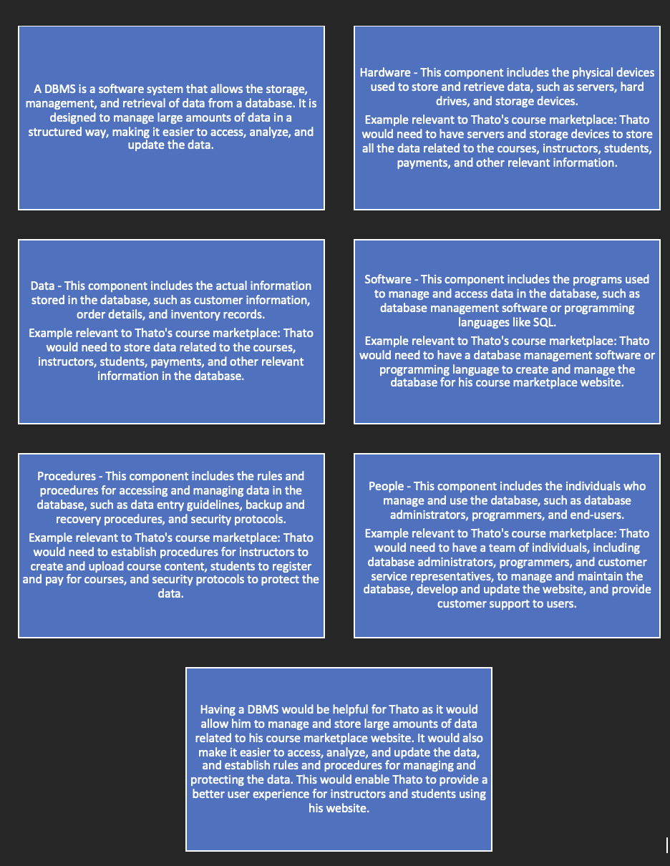

# Question 2 – Types of Databases

1. I would recommend a relational database. Relational databases are ideal for structured data with defined relationships between tables. The data about courses, such as the name of the course, name of the creator, and category, can be organized into separate tables with clearly defined relationships. This allows for easy querying and data retrieval using SQL. Relational databases also have built-in security features to ensure data integrity and protection.
2. I would recommend a NoSQL database. NoSQL databases are ideal for handling unstructured or semi-structured data, such as videos, pictures, and files. NoSQL databases allow for flexible and scalable data storage, and can easily handle large volumes of unstructured data. NoSQL databases also have high availability and scalability, making them ideal for handling large amounts of multimedia files that can be accessed by multiple users simultaneously.

Overall, I would recommend using a combination of both a relational and NoSQL database for Thato's course marketplace website. This would allow him to take advantage of the strengths of each type of database and ensure efficient and effective data management.

# Question 3 – Entity Relationship Diagrams

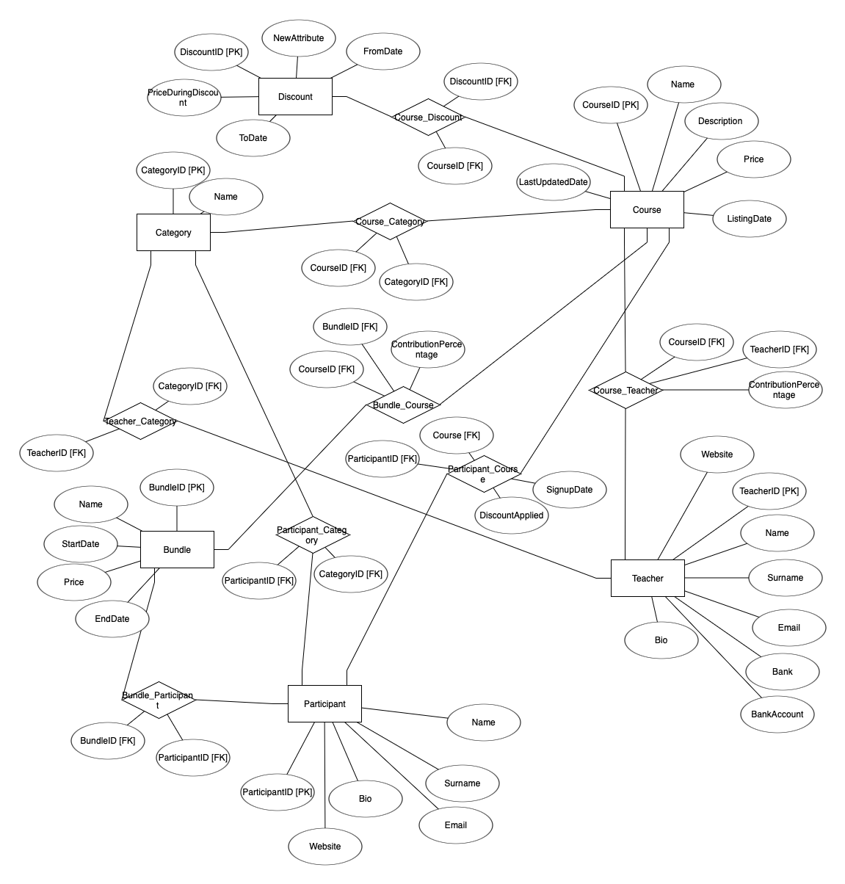

# Question 4 – Entity Relationship Diagram Review

After reviewing the ERD provided by Thato, I would recommend the following 10 changes to improve it and align it with the given business rules:

1. Rename Entity Names: The entities should be named according to the singular form of the corresponding table name. For example, the "Manufacturing Process" entity should be renamed to "Manufacturing" and the "Product Components" entity should be renamed to "Component".
2. Remove the "Product Details" Entity: The "Product Details" entity is not necessary since all the attributes can be included in the "Product" entity.
3. Add Quantity to "Product Components" Entity: The quantity of each component used in a product should be stored in the "Product Components" entity.
4. Change the Cardinality of the "Product Components" and "Component" Relationship: The relationship between "Product Components" and "Component" should be one-to-many (1:M), since a component can be used in multiple products.
5. Add a Primary Key to the "Supplier" Entity: A primary key should be added to the "Supplier" entity to uniquely identify each supplier.
6. Rename the "Production Line" Entity: The "Production Line" entity should be renamed to "Line" to align with the naming conventions.
7. Add a Primary Key to the "Line" Entity: A primary key should be added to the "Line" entity to uniquely identify each production line.
8. Add a "Colour" Attribute to the "Line" Entity: The "Colour" attribute should be added to the "Line" entity to indicate the colour allocated to each production line.
9. Add a Relationship between "Line" and "Product" Entities: A relationship between "Line" and "Product" entities should be added to indicate that each production line manufactures exactly one type of product at a time.
10. Remove the "Manufacturing" Entity: The "Manufacturing" entity is not necessary since it does not add any additional information to the database design.

These changes will ensure that the ERD aligns with the given business rules and can be implemented in a relational database.

# Bibliography

Noor, F., & Abdoos, M. (2019). The importance and application of database management system in organizations. Journal of Advanced Research in Dynamical and Control Systems, 11(Special Issue 1), 292-299.

Roberts, K. (2018). Relational databases vs. NoSQL databases: What’s the difference? IBM Developer. Retrieved from <https://developer.ibm.com/articles/relational-databases-vs-nosql-databases-what-s-the-difference/>

Harrington, J. W. (2017). Relational database design and implementation (4th ed.). Morgan Kaufmann Publishers.